**EECS 360**

**Lab 9**

**Chen Long**

**11/1/2016**

**Objective**

The purpose of this lab is to show us how to use fft function.

**Description**

We were basically doing exactly the same thing besides that we use fft function instead of the summation and we calculate the time the fft function cost compare to the summation. Therefore, we keep everything the same but add the function of y=fft(x), which x is exp(-t). We then compare the graph of the fft to the summation,

**Result**

**we found out that when the period increases, the more accurate we will obtain. We can also observe that if we can only use a small amount of period, we should use the summation since it’s more accurate on small period amount. What I found is weird is that there is a big different on the phase if the period is big, that I don’t know why so far. However, we found that the time consume of fft is really small compare to the summation!**

**Conclusion**

**This lab is more likely just a review for what we have learned last week, but this could be a really helpful tool for us to use MATLAB when we need to use it since it is simpler than the summation.**

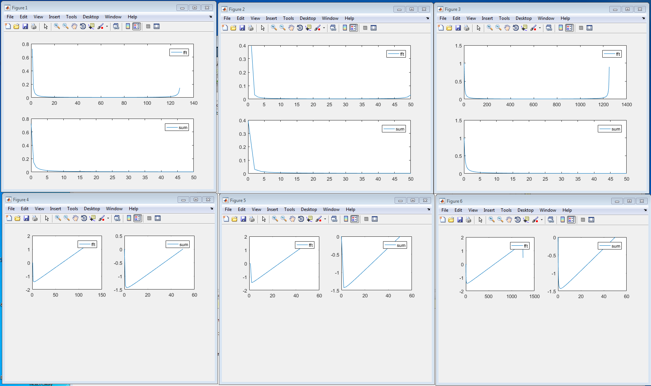

**Code**

clear all;

T=1.28;

fo=1/T;

f=0:fo:50;

tau=0.01;

M=T/tau;

m=0:M-1;

n=f/fo;

f=0:fo:50;

t=m*tau;

x=exp(-t);

tic

y=fft(x);

tfft1=toc;

y=y*tau;

sum=0;

tic

for m=0:M-1

sum=sum+(exp(-1*tau*m)*exp((-j*2*pi*n*m)/M));

end

tsum1=toc;

sum=sum*tau;

figure(1);

subplot(211);

plot(abs(y));

legend('fft')

subplot(212);

plot(f,abs(sum));

legend('sum')

% Figure angle

figure(4);

subplot(221);

plot(angle(y));

legend('fft');

subplot(222);

plot(f,angle(sum));

legend('sum')

% T = 0.5

figure(2);

T=0.5;

fo=1/T;

f=0:fo:50;

tau=0.01;

M=T/tau;

m=0:M-1;

n=f/fo;

f=0:fo:50;

t=m*tau;

x=exp(-t);

tic

y=fft(x);

tfft2=toc;

y=y*tau;

sum=0;

tic

for m=0:M-1

sum=sum+(exp(-1*tau*m)*exp((-j*2*pi*n*m)/M));

end

tsum2=toc;

sum=sum*tau;

subplot(211);

plot(abs(y));

legend('fft')

subplot(212);

plot(f,abs(sum));

legend('sum')

% Figure angle

figure(5);

subplot(221);

plot(angle(y));

legend('fft');

subplot(222);

plot(f,angle(sum));

legend('sum');

% T = 12.5

figure(3);

T=12.5;

fo=1/T;

f=0:fo:50;

tau=0.01;

M=T/tau;

m=0:M-1;

n=f/fo;

f=0:fo:50;

t=m*tau;

x=exp(-t);

y=fft(x);

tic

y=y*tau;

tfft3=toc

sum=0;

tic

for m=0:M-1

sum=sum+(exp(-1*tau*m)*exp((-j*2*pi*n*m)/M));

end

tsum3=toc

sum=sum*tau;

subplot(211);

plot(abs(y));

legend('fft')

subplot(212);

plot(f,abs(sum));

legend('sum')

% Figure angle

figure(6);

subplot(221);

plot(angle(y));

legend('fft');

subplot(222);

plot(f,angle(sum));

legend('sum');